Campus Event Management System

A

Skill Oriented Course Web Application / Project report submitted in the partial fulfillment of the requirements for the award of the Degree of

BACHELOR OF TECHNOLOGY

In

COMPUTER SCIENCE AND ENGINEERING

By
MIRIYALA HARSHADU SRI KRISHNA 24761A05G6

Under the esteemed guidance of

Mr. N. SrinivasaRao

Sr. Assistant Professor


DEPARTMENT OF COMPUTER SCIENCE AND ENGINEERING
LAKIREDDY BALIREDDY COLLEGE OF ENGINEERING (AUTONOMOUS)
Accredited by NAAC with ‘A’ Grade & NBA (Under Tier - I),
An ISO 21001:2018, 14001:2015, 50001:2018 Certified Institution
Approved by AICTE, New Delhi and Affiliated to JNTUK, Kakinada
L.B. REDDY NAGAR, MYLAVARAM, NTR DIST., A.P. - 521230.
2024-2028

LAKIREDDY BALI REDDY COLLEGE OF ENGINEERING (AUTONOMOUS)
Accredited by NAAC with ‘A’ Grade & NBA (Under Tier - I),
An ISO 21001:2018, 14001:2015, 50001:2018 Certified Institution
Approved by AICTE, New Delhi and Affiliated to JNTUK, Kakinada
L.B. REDDY NAGAR, MYLAVARAM, NTR DIST., A.P. - 521230.

Department of
COMPUTER SCIENCE AND ENGINEERING

CERTIFICATE
This is to certify that the Skill Oriented Course Web Application / Project entitled “Campus Event Management System” is being submitted by
MIRIYALA HARSHADU SRI KRISHNA 24761A05G6
in partial fulfillment of the requirements for the award of degree of B.Tech in Computer Science and Engineering from Jawaharlal Nehru Technological University Kakinada is a record of Bonafide work carried out by him/her at Lakireddy Bali Reddy College of Engineering (Autonomous).

The results embodied in this Skill Oriented Course Web Application / Project report have not been submitted to any other university or institute for the award of any degree or diploma.

INTERNAL EXAMINER EXTERNAL EXAMINER

ACKNOWLEDGEMENT

I would like to thank Mr. N. SrinivasaRao, Sr. Assistant Professor, CSE department for the encouragement and support in carrying out this Skill Oriented Course Web Application / Project.

I also take the privilege to record my thanks to Dr. S. Nagarjuna Reddy, Professor, Head of the Department of CSE whose encouragement, cooperation, and valuable support crown my success.

I express my thanks to the support given by management in completing my Web Application / Project. I also express my sincere gratitude & deep sense of respect to Dr.K. Appa Rao, Principal for making us available all the required assistance and his support and inspiration to carry out this Skill Oriented Course Web Application / Project in the Institute.

I am thankful to the teaching and non-teaching staff of CSE department for their direct as
well as indirect help in my Skill Oriented Course Web Application / Project.

I am elated to avail myself to this opportunity to express my deep sense of gratitude to my parents.

MIRIYALA HARSHADU SRI KRISHNA 24761A05G6

DECLARATION

I am here to declare that the project entitled “Campus Event Management System” work done by me. I certify that the work contained in the report is original and has been done by me under the guidance of my supervisor. The work has not been submitted to any other institute in preparing for any degree or diploma. I have followed the guidelines provided by the institute for preparing the report. I have confirmed the norms and guidelines given in the Ethical Code of Conduct of the Institute. Whenever I have used materials (data, theoretical analysis, figures and text) from other sources, I have given due credit to them by citing them in the text of the report and giving their details in the references. Further, I have taken permission from the copyright owner of the sources, whenever necessary.

Signature of the student

MIRIYALA HARSHADU SRI KRISHNA 24761A05G6
ABSTRACT
Campus Event Management System is a role-based Java web application for coordinating college events and participant registrations. It provides separate participant and organizer dashboards, allowing students to browse events and retrieve passes while organizers maintain event information and inspect registration records. The application replaces disconnected notices and manual lists with a central MySQL database containing users, events, and registrations.
Participants create accounts using a unique roll number, email, and phone number. An email OTP verifies ownership before submission, and BCrypt cost factor 12 protects stored passwords. Students filter events by category and department, inspect complete descriptions, and register while deadlines and capacity permit. Completed registration generates a unique pass ID, triggers a confirmation email, and opens the registered-events section. Profiles display the uploaded photograph and participant details.
Organizers use a seeded account and complete email OTP authentication after password verification. They create, view, update, and delete events, upload images, control availability, and search reports using event, college, department, year, and participant information. The implementation uses HTML, CSS, JavaScript, JSP, Servlets, JDBC, MySQL, JavaMail, Maven, and Tomcat 9. HttpSession maintains login state until logout or timeout. Payment is currently simulated as PAID.
LIST OF CONTENTS
CONTENTS PAGE NO
1. INTRODUCTION 1-5
1.1. Overview of the Project 1-4
1.2. Feasibility Study 5
2. TECHNOLOGIES USED 6-20
2.1. HTML, CSS & JavaScript 6-9
2.2. JDBC (MYSQL) 10-12
2.3. Servlets 13-19
2.4. JSP 20
3. WEB APPLICATION ARCHITECTURE 21
4. CODING & IMPLEMENTATION 22-36
5. RESULTS 37-38
6. CONCLUSION 39
7. REFERENCES 40
LIST OF ABBREVIATIONS
HTML - Hypertext Markup Language
CSS - Cascading Style Sheets
JS - JavaScript
JSP - JavaServer Pages
JDBC - Java Database Connectivity
JDK - Java Development Kit
JVM - Java Virtual Machine
SQL - Structured Query Language
DBMS - Database Management System
HTTP - Hypertext Transfer Protocol
SMTP - Simple Mail Transfer Protocol
TLS - Transport Layer Security
OTP - One Time Password
CRUD - Create Read Update Delete
DAO - Data Access Object
MVC - Model View Controller
WAR - Web Application Archive
BLOB - Binary Large Object
1. INTRODUCTION
1.1. Overview of the Project
1.1.1. Campus Event Administration
Colleges conduct technical competitions, workshops, seminars, sports tournaments, and cultural programmes throughout the academic year. Every activity requires information about its schedule, venue, eligibility, registration deadline, and participants. When these details are distributed across notices, messages, and handwritten lists, students must consult several sources and organizers must reconcile records manually. A shared application provides a consistent place to publish event information and maintain registration records.
1.1.2. Project Purpose
Campus Event Management System is a Java web application developed to coordinate these activities. It provides two account roles: participants and organizers. Participants discover available events, view complete descriptions, register for events, and retrieve their registration passes. Organizers publish and maintain events, inspect registration counts, and search participant records. Separate dashboards present the actions appropriate to each role.
1.1.3. Implemented Platform
The browser interface uses HTML, CSS, and JavaScript, while JavaServer Pages produce the server-rendered screens. Java Servlets process requests, JDBC connects the application to MySQL, and Apache Tomcat 9 runs the deployed WAR file. JavaMail sends email messages through Gmail SMTP. This combination demonstrates the interaction between frontend controls, server-side workflows, relational storage, and external communication in one full stack development project.
1.1.4. Central Records
The database stores users, events, and registrations. A student roll number identifies each participant and acts as the login username. Unique email and phone values reduce duplicate identities. Each event has its own details, image, capacity, fee, and registration deadline. A registration links one participant to one event and stores a unique pass identifier, payment status, and registration timestamp.
1.1.5. Application Scope
The present implementation covers verified participant onboarding, authenticated navigation, event CRUD, registration, profile display, and organizer reporting. Payment is simulated and recorded as PAID rather than processed through a financial service. Participant cancellation and feedback are outside the requested scope. These boundaries keep the mini project focused on the required campus workflows without presenting unimplemented features as completed capabilities.
1.1.6. Problem Statement and Objectives
1.1.6.1. Existing Coordination Problems
Manual registration methods create repeated work whenever an event changes or additional participants join. Organizers may maintain different copies of a list, making counts and contact information difficult to verify. Students may find an announcement but lack a clear way to confirm whether their registration succeeded. A system must therefore connect event publication, account identity, registration status, and reporting rather than treat each as an isolated task.
1.1.6.2. Participant Objectives
The participant interface should make the current event catalogue easy to understand. Students need image cards, concise event metadata, category and department filters, and a dedicated details view. After registration, the event should appear in a separate registered-events section with a retrievable pass. A complete profile should show the details supplied during account creation and the uploaded profile photograph.
1.1.6.3. Organizer Objectives
Organizers need to create events with mandatory attributes, upload images, and set closing times before event start. They must be able to update or delete event records and inspect registration counts. Reports should support both text search and structured filters so organizers can locate participants by event, college, department, study year, or identifying information without exporting and manually sorting every record.
1.1.6.4. Identity and Access Objectives
The system should verify participant email ownership before accepting account registration. Roll number, email address, and phone number must be unique. Passwords should be hashed using BCrypt with cost factor 12. Organizer accounts should not be available through public self-registration, and organizer login should require a separate email OTP after the username and password are validated.
1.1.6.5. Expected Functional Outcome
A successful workflow begins with a verified account and ends with a consistent registration record and unique event pass. The application should reject duplicate registrations, closed events, and events without remaining capacity. It should maintain the authenticated session across protected pages and invalidate that session at logout. These concrete behaviours define the intended outcome more precisely than the appearance of individual pages alone.
1.1.7. Users and Functional Requirements
1.1.7.1. Participant Account Requirements
Participant registration collects full name, roll number, email, phone, college, department, study year, gender, address, profile photo, password, and confirmation password. All fields are mandatory. Standard values use dropdown lists, including the nine departments and years 1 through 4. Radio buttons collect gender, the address uses a text area, and an upload control accepts the photograph. The form also provides Submit, Reset, and password visibility controls.
1.1.7.2. Participant Event Requirements
The participant sidebar contains Dashboard, Available Events, Registered Events, and Profile. Dashboard cards show event counts and links to the corresponding lists. Available Events includes open events even when the participant has already registered. In that case, a green Already Registered button replaces Register now and opens a dialog containing participant and pass details. Both lists support category and department filters.
1.1.7.3. Organizer Requirements
An organizer uses the same login screen but completes an additional email OTP step. The organizer sidebar contains Dashboard, All Events, Registration Reports, and Profile, with a New Event action. All Events includes active and inactive records. Create, edit, view, and delete actions maintain events; the Members action opens the report screen for the selected event. Organizer registration is not exposed on the public registration form.
1.1.7.4. Event and Report Requirements
Events require title, description, category, department, venue, date and time, registration closing time, capacity, fee, and image. The description appears after selecting View rather than on the card. Reports display participant identity, contact information, college, department, year, pass, payment status, and registration time. Search can be combined with event, college, department, and year filters.
1.1.7.5. Navigation and Communication Requirements
Back from event details returns to the relevant event list. Successful event registration redirects to Registered Events, while unsuccessful attempts return to Available Events with a status message. Email communication includes participant verification OTP, organizer login OTP, an account welcome message, and an event registration receipt. Email delivery does not replace persistent registration storage; saved records remain available through the application.
1.1.8. System Design and Data Requirements
1.1.8.1. Layered Application Design
The project separates browser presentation from request processing and persistence. JSP views render form and dashboard content using data provided by Servlets. Controllers validate requests, inspect session identity, and call data-access or email services. Model objects carry account, event, pass, and report data. AppDao handles queries and database changes so the JSP pages do not need to manage JDBC connections directly.
1.1.8.2. User Information
The users table uses roll_no as its primary key and stores the account name, email, phone number, college, password hash, role, department, study year, gender, address, photograph, photograph MIME type, and creation time. Email and phone uniqueness support the application checks. Password confirmation is used only during validation and is not stored. The public form creates PARTICIPANT accounts rather than accepting a submitted organizer role.
1.1.8.3. Event Information
The events table stores the event identifier and descriptive, scheduling, capacity, fee, image, organizer, availability, and creation attributes. The organizer_id foreign key relates the event to a user. Registration_closes_at is distinct from event_date, allowing registration to close before the event begins. The event image is stored as binary data with a MIME type and is served through a dedicated authenticated endpoint.
1.1.8.4. Registration Information
The registrations table connects participant_id and event_id. Each record contains a unique pass_id, payment_status, and registered_at value. A database unique constraint on the participant and event pair prevents repeated registration. Foreign keys maintain valid references, and deleting an event cascades to its registration records. A participant can therefore register for several different events without duplicating the participant profile.
1.1.8.5. Validation and State
Browser validation improves immediate feedback, while server validation enforces rules for all submitted requests. Temporary OTP state is kept in the session instead of being represented by a permanent verified column. Authenticated state is also stored in HttpSession. This makes the application stateful: the server remembers the logged-in account and applies that identity to protected requests until logout or session expiration.
1.2. Feasibility Study
1.2.1. Technical Feasibility
The implementation uses Java 17, Maven, MySQL, and Tomcat 9, all of which are available in the development environment. Its javax.servlet imports require a compatible Servlet container. A standard browser runs the frontend without a separate JavaScript framework build. SMTP connectivity is needed for live OTP delivery, and the database service must be running before the initialization listener can prepare the schema and organizer account.
1.2.2. Operational Feasibility
Users interact with familiar controls and named sidebar sections. Fixed college, department, category, and year values reduce inconsistent spelling. Participants can confirm registration by revisiting Registered Events, while organizers can inspect reports without maintaining separate lists. Readable status messages distinguish validation failures, expired OTPs, duplicate identities, and successful registration. These choices support classroom demonstration and ordinary use by students and staff.
1.2.3. Resource Feasibility
The mini project can run on an existing development computer with a browser, JDK, Maven, MySQL, and Tomcat. Images are stored in the database, keeping deployment simpler for a small installation. A larger installation would need resource planning for database size, email volume, backup, and hosting. The report does not assume measured performance or cost savings that have not been established through deployment testing.
1.2.4. Security Boundaries
The implemented foundation includes password hashing, session renewal during authentication, protected routes, role checks, prepared statements, and uniqueness constraints. These controls do not make the classroom application automatically production-ready. A public deployment would require externalized secrets, secure transport, request-rate controls, CSRF protection, monitoring, and tested recovery procedures. Demonstration accounts and SMTP credentials should be handled separately from production configuration.
1.2.5. Functional Boundaries
Current payment handling is a demonstration status, not a financial transaction. There is no cancellation workflow, feedback module, public organizer registration, or password-recovery screen. Future extensions may add a verified payment gateway, QR check-in, report export, and administrative account management. The completed core remains a coherent event portal covering account verification, event publication, registration persistence, pass retrieval, and organizer reporting.
2. TECHNOLOGIES USED
2.1. HTML, CSS & JavaScript
2.1.1. Page Structure
HTML defines the visible structure of the Campus Event Management System. Headers identify the application and account, side navigation groups dashboard sections, and main content areas contain forms, event cards, profiles, and reports. Labels are associated with their controls so users can identify the required value. Buttons and links have different responsibilities: buttons submit an action, while links move between clean Servlet routes.
2.1.2. Registration Controls
The participant form demonstrates the required HTML control types. Text inputs collect identity and contact values; password inputs collect the password and confirmation. A textarea collects the address, dropdowns collect college, department, and year, and radio buttons collect gender. A file input selects the profile photo. The show-password checkbox changes visibility without altering the submitted password value, and Submit and Reset support completion and clearing.
2.1.3. Event Controls
The organizer form contains title, category, department, venue, event date, start time, closing date, closing time, capacity, fee, description, image upload, and availability controls. Date and time use separate inputs so the user can select both parts explicitly. Numeric controls restrict negative fees and capacities below one at the browser level. Multipart form encoding enables the uploaded image bytes to reach EventServlet.
2.1.4. Cards and Details
Event cards show a preview image and essential metadata with View and Register now actions. Descriptions are reserved for the details screen to keep browsing readable. Registered cards provide a Details button, and the HTML dialog element presents pass information over the list. Returning from the dialog closes it without replacing the events section. Already Registered is also an action that retrieves those saved details.
2.1.5. Client and Server Roles
Required attributes and input types provide useful initial checks, but they are not the final authority. A crafted request could omit or change any field. The server therefore validates mandatory data, allowed dropdown values, uploaded files, dates, uniqueness, and account role again. HTML makes the interaction understandable, while Servlet validation and database constraints determine whether the operation is accepted.
2.1.6. CSS and Responsive Presentation
2.1.6.1. Shared Styles
The application uses a shared stylesheet for both account roles. It defines the page background, typography, colours, borders, buttons, inputs, messages, cards, and table presentation. Reusing these rules keeps the login form, participant dashboard, organizer dashboard, and event form consistent. The design uses straightforward CSS and avoids animation, allowing the interface to remain clear during ordinary navigation and classroom evaluation.
2.1.6.2. Dashboard Layout
The desktop dashboard combines a top bar, a left sidebar, and a main panel. The top bar identifies the current account and provides logout. The sidebar exposes only the role-specific sections. Main panels provide summary cards, event grids, reports, or profile information. Active sidebar styling identifies the selected endpoint so a page reached through filtering still indicates the correct section.
2.1.6.3. Cards and Action States
Cards use consistent image areas and content spacing. Button styles differentiate primary actions, secondary navigation, success states, and destructive actions. The green Already Registered state communicates a completed registration and remains clickable for pass details. A separate delete style helps identify organizer deletion, while a confirmation prompt reduces accidental activation. Event cards show concise data instead of expanding the description inside every card.
2.1.6.4. Forms and Reports
Form grids align related controls, including password and confirmation fields. Filter forms align category and department dropdowns with Apply filters and Clear actions. Table borders and row spacing separate organizer report fields. A horizontal table container supports wide report data on narrow displays. Profile layouts organize the photograph and a labelled details list, giving identity and contact information a predictable reading order.
2.1.6.5. Responsive Behaviour
Media queries adjust grids, sidebars, toolbars, and form columns as screen width decreases. Content can stack into fewer columns rather than forcing every desktop row into a small viewport. Images preserve useful proportions, and table scrolling protects report columns. Readable foreground and background contrast is essential because a role label or action is not usable if it visually disappears into its surrounding surface.
2.1.7. JavaScript Validation and Interaction
2.1.7.1. Immediate Feedback
JavaScript supports interactive checks before a form is submitted. It can identify missing fields, compare the password and confirmation values, enforce the configured password pattern, and provide messages near the relevant control. Immediate feedback reduces repeated form submissions. The final registration decision still belongs to the server because client scripts may be disabled or bypassed.
2.1.7.2. Email Verification Interface
The registration interface submits OTP actions to /registration-email-otp. A send action includes the email address, and a verify action includes the email and received code. The endpoint returns JSON containing a success flag and a status message. The browser displays whether the code was verified, invalid, expired, or unavailable, and permits final submission only when verification succeeds for the current email.
2.1.7.3. Password Visibility
The registration form has a Show password checkbox below the password and confirmation controls. The login screen provides an eye control for its password field. JavaScript changes the input type between password and text to support these interactions. This does not change the actual credential, and visibility should remain a user-controlled temporary display choice rather than a separate stored preference.
2.1.7.4. Dates and Dialogs
The event form updates the maximum registration closing date when an event date is selected. Registration closing controls are unavailable until an event date is present, and the submitted closing time must be before event start. Registration-details buttons identify a dialog for the relevant event. JavaScript opens that dialog while the dialog form closes it using its Back control.
2.1.7.5. Filters and Navigation
Event filtering is handled through GET forms and query parameters rather than a client-only hidden list. The selected category and department are submitted to /events or /registrations, and the server returns matching data with the dropdown selection retained. This makes the endpoint responsible for the result. JavaScript enhances page interaction, while normal form and link behaviour continue to define the navigation flow.
2.1.8. Java Models and Package Organization
2.1.8.1. Java Runtime
The project compiles for Java 17. This supports the language features used by the models and controllers, including records, modern switch expressions, and stream filtering. Maven declares the compiler release so a deployment does not accidentally build against an incompatible Java level. Tomcat must run with a compatible JDK to load the generated application classes.
2.1.8.2. Model Objects
Event is a record containing the identifier, descriptive information, category, department, venue, dates, capacity, fee, image availability, organizer, active status, and registration count. ParticipantEventRegistration combines an Event with pass, payment, and registration-time data. RegistrationRecord carries a complete organizer report row, avoiding repeated account lookups when the JSP displays the report table.
2.1.8.3. User Identity
User is an immutable Serializable class representing the authenticated identity and profile. It contains roll number, name, email, phone, college, password hash, role, department, study year, gender, and address. The session stores the User object after authentication. JSP pages use its accessors for display, while Servlets inspect its role before accepting organizer-only or participant-only operations.
2.1.8.4. Packages
The com.dao package provides connection setup and database operations. The com.model package contains the data representations. com.servlets contains request controllers, the authentication filter, image responses, and the application lifecycle listener. com.service holds email composition and delivery, and com.util provides password hashing and verification. These boundaries make it easier to locate behaviour without reading every source file.
2.1.8.5. Resource and Error Handling
JDBC and image input resources use try-with-resources so they close after normal completion or an exception. Controllers distinguish validation problems from infrastructure failures where appropriate and log exceptions for diagnosis. Model objects pass data between layers, while response redirects and request attributes determine what the browser sees. These responsibilities keep storage and presentation from becoming one large class.
2.2. JDBC (MYSQL)
2.2.1. Connection Setup
Dao configures the MySQL JDBC connection using DB_URL, DB_USER, and DB_PASSWORD, with local development defaults. MySQL Connector/J supplies the driver implementation. AppDao obtains connections when it performs operations and closes them after use. The JDBC URL selects the event database and configures the application time zone, making connection setup a shared concern rather than repeating it across every Servlet.
2.2.2. Prepared Statements
PreparedStatement binds submitted values through parameters. Participant identifiers, emails, phones, event attributes, search terms, and report filters are not directly concatenated into SQL expressions. The SQL structure remains separate from the supplied values. This is particularly important for text search and registration data because those values originate in browser requests and may contain punctuation or unexpected input.
2.2.3. Mapping Results
ResultSet exposes rows returned by queries. AppDao maps those columns into User, Event, ParticipantEventRegistration, or RegistrationRecord objects. Event queries also calculate registration counts. Registration report queries join users, events, and registrations so a report row can contain identity, event, pass, and payment information. JSP pages therefore receive ready-to-display data structures rather than open database resources.
2.2.4. Binary Data
Profile and event images are saved using byte arrays with their MIME types. Dedicated DAO methods retrieve image bytes and type information. Image Servlets set the response content type and length before writing the bytes. This approach keeps image delivery within the same authenticated application flow and avoids requiring a deployment-specific path for each uploaded photo.
2.2.5. Initialization and Transactions
AppDao.initialize creates the required tables, checks schema requirements, and seeds the initial organizer. DatabaseSetup provides a command-line entry point to the same process. Event registration uses transaction handling so its availability check and insert can be completed consistently or rolled back. SQL exceptions are propagated to controllers, which decide whether to show a user-facing message or log an infrastructure failure.
2.2.6. MySQL Tables and Attributes
2.2.6.1. Relational Storage
MySQL stores the persistent state of the application in the event database. The design uses three core tables instead of repeating student information for each event. The account table stores identity, the event table stores the published activity, and the registration table records their association. Appropriate data types distinguish textual descriptions, decimal fees, date-time values, images, and generated identifiers.
2.2.6.2. Users Table
The users columns are roll_no, full_name, email, phone_number, college_name, password_hash, role, department, study_year, gender, address, profile_photo, profile_photo_type, and created_at. roll_no is the primary key. Email and phone are unique. Student-specific columns describe participants, while a seeded organizer primarily requires identity, email, password hash, and role. Password confirmation and OTP values are not permanent user attributes.
2.2.6.3. Events Table
The events columns are id, title, description, category, department, venue, event_date, registration_closes_at, capacity, fee, image_data, image_type, organizer_id, active, and created_at. id is generated automatically. A separate closing timestamp makes registration eligibility explicit. The active flag allows organizers to disable an event without deleting the record. The image and its MIME type support display through the event-image endpoint.
2.2.6.4. Registrations Table
The registrations columns are id, event_id, participant_id, pass_id, payment_status, and registered_at. The participant and event identifiers are foreign keys. pass_id is unique, and the event-participant pair is also unique. payment_status supports PAID and PENDING values, although the current demonstration registration path records PAID. registered_at retains when the association was created.
2.2.6.5. Controlled Values
Application dropdowns limit departments, event categories, study years, and college names. The server validates those choices rather than assuming the form supplied an allowed value. Database uniqueness and relationships complement these checks. Email verification is kept as temporary session state before participant submission, so the current user schema does not require an interests field, an identity-file field, or a permanent verified flag.
2.2.7. MySQL Relationships and Consistency
2.2.7.1. Relationships
One organizer can publish many events through events.organizer_id. One participant can register for many events, and one event can have many participants. The registrations table resolves this many-to-many relationship by storing one row for each association. User profile data is maintained once, while event and pass information are associated through keys. Organizer reports retrieve a combined view with joins.
2.2.7.2. Duplicate Protection
The roll number primary key and unique email and phone indexes prevent repeated account identities. The unique participant-event pair prevents the same student registering twice for one event. A unique pass ID provides another identifiable record value. Browser and Servlet checks offer helpful feedback, while the database constraints continue to apply if requests arrive nearly together or a client bypasses the normal interface.
2.2.7.3. Capacity and Deadlines
Before registration, the DAO checks event availability, registration closing time, and current count against capacity. The registration transaction coordinates the check with insertion. The event lookup uses a locking query in that transaction so concurrent registrations are handled against the event state consistently. A failed operation is rolled back rather than leaving a partial registration presented as a completed result.
2.2.7.4. Deletion Behaviour
Deleting an event removes its associated registration rows through the event foreign key cascade. Organizers receive a confirmation prompt because the deletion affects member records as well as the event card. Participant cancellation is not provided by the current application. The deletion rule should therefore be understood as an organizer administrative operation, not a public way for participants to remove registrations.
2.2.7.5. Reporting and Maintenance
Queries combine event title, participant identity, academic information, pass ID, payment state, and registration time. Search conditions can be combined with structured filters. Normalized records make these queries possible without reconciling separate spreadsheets. Backups and migration practices would be needed for deployment beyond the classroom, especially because the database also stores uploaded image BLOBs and account information.
2.3. Servlets
2.3.1. Controller Layer
A Servlet receives HTTP requests through an annotation-mapped URL. The application uses routes such as /login, /events, /event, /registration, and /reports. These URLs expose application functions rather than JSP filenames. The container creates and manages Servlet instances, provides request and response objects, and makes session state available through HttpServletRequest.
2.3.2. GET Requests
GET requests load views, filtered lists, details, or images. DashboardServlet selects the dashboard, events, registrations, or profile section from the requested path. EventServlet loads an event when an id is supplied or presents the new-event form to an organizer. The image Servlets return binary bytes rather than forwarding to a JSP. ReportServlet builds the organizer registration list from submitted filter parameters.
2.3.3. POST Requests
POST requests process actions that submit account or application data. Login checks credentials, RegisterServlet saves a participant, EventServlet maintains events, and RegistrationServlet creates event registrations. Logout invalidates authenticated state through POST. Multipart requests carry image uploads. Controllers validate parameters and roles before calling AppDao, rather than trusting which button or link originally produced the request.
2.3.4. Forwarding and Redirecting
A request forward renders a JSP while retaining request attributes, such as an event model or validation message. A redirect asks the browser to make a fresh request to a clean route. Successful event registration redirects to /registrations, and successful event maintenance redirects to /events. This separates submission from the next display request and reduces accidental repetition when the page is refreshed.
2.3.5. Shared Protection
AuthFilter checks protected requests for an authenticated session user. If authentication is absent, it redirects to login with a session-required status. It also sets cache-control headers on protected responses. Individual controllers apply the additional role rules required by an operation. This combination separates general session access from the specific permission to register for an event or administer event records.
2.3.6. Authentication and Registration Servlets
2.3.6.1. Participant Login
The login controller accepts the submitted roll number and password. It normalizes the identifier, obtains the stored user through AppDao, and verifies the supplied password using PasswordUtil. Incorrect credentials return a login error. For a participant, successful verification creates an authenticated session and redirects to the dashboard. The server does not store or compare plaintext passwords in the database.
2.3.6.2. Organizer Login
An organizer must complete another step after the password succeeds. The controller generates a random six-digit code, stores pending organizer state and an expiry time, and sends the code to the organizer email. OtpServlet displays and verifies this challenge. The organizer becomes an authenticated user only after a valid unexpired code is submitted, and the pending session is replaced.
2.3.6.3. Participant Registration
RegisterServlet processes the public multipart form and creates PARTICIPANT accounts only. It validates required identity, contact, college, department, year, gender, address, password, and photo values. Before saving, it confirms that the submitted email matches the verified registration email held in the session. The password is hashed with BCrypt, and a welcome message is attempted after account creation.
2.3.6.4. Uniqueness and Messages
Roll number, email, and phone number are checked for conflicts before insertion. Database constraints remain the final safeguard against concurrent requests. The controller translates duplicate-value cases into appropriate already-exists messages rather than exposing raw SQL errors. Registration errors can be returned to the form, while a successful account creation sends the participant to login with a completion status.
2.3.6.5. Session Completion
LogoutServlet invalidates the current session and redirects to login. Temporary OTP values are cleared after successful verification. web.xml defines cookie-based tracking, an HttpOnly session cookie, and a thirty-minute timeout. Login and OTP handling create fresh authenticated session state so pending authentication does not remain the active session after sign-in. These transitions connect credentials, OTP, dashboard access, and logout into one lifecycle.
2.3.7. Event Registration and Report Controllers
2.3.7.1. Event Maintenance
EventServlet handles organizer creation, editing, and deletion. It accepts mandatory title, description, category, department, venue, scheduling, capacity, fee, image, and active-state data. Validation rejects unknown category or department values, invalid numeric values, and registration closing times that are not in the future or do not precede the event start. An existing image can be retained during editing when no replacement is uploaded.
2.3.7.2. Event Views
For a participant, EventServlet renders a read-only detail presentation with the image, description, department, date, closing time, venue, and fee. The from parameter identifies whether Back should return to Available Events or Registered Events. Organizers see the edit form for the same event. This shares retrieval logic while maintaining the different actions available to each role.
2.3.7.3. Participant Registration
RegistrationServlet accepts an eventId only from a signed-in participant. It loads the event, calls AppDao to create the registration, and attempts the confirmation email. Success stores a flash message with the pass ID and redirects to /registrations. Invalid, unavailable, or duplicate requests receive an appropriate message and return to the available-events workflow rather than the summary dashboard.
2.3.7.4. Dashboard Filtering
DashboardServlet supplies lists and summary data to the role-specific JSP. For participants, it retrieves active available events and that participant's registrations. Category and department filtering is applied only to the currently requested list, retaining the other data needed for registration state. For organizers, the All Events list includes inactive records and supports the same two event filters.
2.3.7.5. Reports
ReportServlet is restricted to organizers. It reads eventId, collegeName, department, year, and search, obtains matching records, and forwards them into the report section of the organizer dashboard. Event member links preselect an event. Invalid numeric filter values are rejected instead of being silently accepted. The resulting table includes participant contact and academic data with pass, payment, and registration-time information.
2.3.8. Sessions and Role Based Access
2.3.8.1. Stateful Behaviour
The application uses HttpSession and is therefore stateful. After authentication, the server retains a User object and uses it to identify later protected requests. The browser carries the session cookie instead of resubmitting credentials for each page. The session can also contain temporary OTP data and a flash message intended for the next page after a redirect.
2.3.8.2. Authentication Transitions
Login checks the BCrypt password hash before establishing identity. A participant receives a fresh authenticated session. An organizer first receives a short-lived pending session containing the user and code, then OtpServlet creates a new authenticated session after successful OTP verification. This separates possession of correct credentials from completion of the organizer's second authentication step.
2.3.8.3. Route Protection
AuthFilter checks dashboard, event, registration, profile, report, image, and logout paths for the authenticated user. Missing state redirects to login with a session-required status. Protected responses also receive no-cache headers. The filter controls general entry to authenticated routes, while the Servlet responsible for an operation checks the role and resource permissions required to execute it.
2.3.8.4. Role Boundaries
Participants can view event information and their own registrations and profile. Organizers maintain events and inspect participant report records. ProfilePhotoServlet allows a participant to read their own photograph and allows organizer access to participant photographs. Organizer-only checks protect event mutations and reports even if a participant manually submits a request to a known URL.
2.3.8.5. Session End
web.xml configures a thirty-minute timeout, cookie-based tracking, and an HttpOnly cookie. LogoutServlet invalidates the session and returns to login. OTP values are removed after verification and expire if not used in time. A production deployment should additionally use suitable secure-cookie and HTTPS configuration, alongside request forgery and rate protections appropriate to its hosting environment.
2.3.9. Email OTP and SMTP Service
2.3.9.1. Email Responsibilities
EmailService composes and sends messages for participant email verification, participant account creation, organizer login verification, and event registration confirmation. The service centralizes formatting so controllers do not repeat a full HTML email template. Messages use a consistent application identity, readable headings, detail rows, and security notices suitable for the specific workflow.
2.3.9.2. Participant Verification
RegistrationEmailOtpServlet creates a random six-digit code and stores it with the email and an expiration timestamp in the registration session. The send action delivers the code; the verify action checks the submitted value, matching email, and expiry. Successful verification stores the verified email for RegisterServlet and clears the pending code values. The visible status explains whether the form can now be submitted.
2.3.9.3. Organizer Verification
Organizer OTP is sent only after a valid organizer username and password. The pending state is separate from the authenticated session. OtpServlet verifies the code and expiry before creating the final session user. This prevents successful password verification alone from opening the organizer dashboard. The same common login page can therefore support both roles while applying the additional organizer requirement.
2.3.9.4. SMTP Delivery
JavaMail connects to Gmail SMTP using authentication and STARTTLS on the configured submission port. Environment settings can supply the host, port, user, and sender. The classroom source currently contains an app password; it should be moved to protected configuration before distribution. The report does not need to reproduce the secret to explain the connection or email workflow.
2.3.9.5. Receipts and Failure Handling
The event registration receipt contains the event title, date and time, venue, pass ID, payment status, and amount. The current amount is descriptive because payment itself is simulated. Registration is stored before the message is attempted. If SMTP delivery fails afterward, the error is logged and the participant can still retrieve the saved pass from Registered Events rather than losing the completed database record.
2.3.10. Validation Passwords and Image Uploads
2.3.10.1. Input Rules
All participant registration fields are mandatory, including the photo. Passwords require 6 to 15 characters with lowercase, uppercase, digit, and special-symbol components. Confirmation must match. Year must be 1 through 4, and college, department, and gender must belong to the accepted values. The server normalizes account identifiers and uses clear validation messages so rejected data can be corrected.
2.3.10.2. BCrypt
PasswordUtil uses the jBCrypt library with a work factor of 12. Hash creation includes a salt, and login verifies the supplied password against the stored hash. The system therefore does not need to store a recoverable password. Password confirmation is not persisted. Classroom account passwords are demonstration values and should not be treated as acceptable shared production credentials.
2.3.10.3. Event Rules
An organizer must provide every event field when creating a record. Capacity must be at least one, fee cannot be negative, and category and department must be valid. Registration closing time must be in the future and earlier than event start. Existing event images can be retained during editing, while a new event requires an initial image upload.
2.3.10.4. File Handling
Multipart requests make uploaded data available through the Servlet Part API. The participant profile-photo upload is limited to 2 MB, while the event image upload is limited to 5 MB. Accepted MIME types are JPEG, PNG, and WEBP. The bytes and content type are stored in MySQL and later streamed from the corresponding image endpoint.
2.3.10.5. Error Feedback
Duplicate account data produces an already-exists message for roll number, email, or phone. Registration failures distinguish invalid selection, duplicates, closed or unavailable events, and other database problems where possible. OTP endpoints return JSON status messages that the page displays. These checks support understandable interaction while preserving the server and database as the authority for whether a requested change is valid.
2.3.11. Maven Tomcat and Deployment
2.3.11.1. Maven Project
pom.xml declares WAR packaging and the Java 17 compiler release. Dependencies provide the Servlet API, MySQL Connector/J, JavaMail, and jBCrypt. The Servlet API is provided by Tomcat rather than bundled as the application runtime. Running mvn package compiles the source and creates target/campus-events.war, which is the deployable application archive.
2.3.11.2. Tomcat Runtime
Apache Tomcat 9 runs the javax.servlet application. The context root is campus-events, and the browser URL includes the configured HTTP port. A local example is http://localhost:8082/campus-events/login, but the actual port follows the Eclipse server configuration. The HTTP and shutdown ports must not already be held by another process when a new server instance starts.
2.3.11.3. Startup and Configuration
AppContextListener calls AppDao.initialize when the application starts. This prepares users, events, and registrations and seeds the initial organizer if absent. Dao reads database environment settings, while email delivery uses SMTP configuration. DatabaseSetup can run the same initializer manually. Initialization failures are logged, so successful deployment should include checking database availability and the server startup log.
2.3.11.4. Project Resources
Java source lives under src/main/java and web content under src/main/webapp. JSP views are inside WEB-INF, with static CSS and JavaScript under assets. Eclipse metadata identifies Java, web facets, and deployment mappings. The target directory holds compiled classes and the WAR, while build is retained for the existing Eclipse setup. Final project documents belong in docs rather than in deployment resources.
2.3.11.5. Verification and Extension
Build success confirms compilation and packaging; it does not alone prove SMTP delivery or every browser workflow. Useful checks include account uniqueness, OTP verification, session logout, organizer event CRUD, filter combinations, deadline and capacity rejection, pass retrieval, and report search. Future production work should add automated tests, reliable secret management, backups, verified payment handling, and an appropriate deployment and monitoring plan.
2.4. JSP
2.4.1. View Responsibilities
JSP views produce the HTML returned to the browser. Servlets prepare the request attributes before forwarding, so the view can render the selected account, event, list, or report. The application places JSP files under WEB-INF/views. This directory is not directly accessible as a public browser path, requiring navigation through the controller endpoints that supply data and enforce access rules.
2.4.2. Authentication Views
login.jsp contains the common login form and status or error messages. register.jsp contains the participant account form, email verification controls, required dropdowns, photo upload, password requirements, and action buttons. verify-otp.jsp accepts the organizer code after the credential stage. Together these views present the inputs required by authentication controllers without providing public organizer self-registration.
2.4.3. Participant View
userdashboard.jsp renders the participant navigation and four sections. It builds event cards from Event objects and determines whether each event has an existing registration. Separate dialogs provide pass details. The profile section presents the photo and labelled personal, contact, college, and academic values. Filters submit to the relevant endpoint, and selected values are reflected when the view is rendered again.
2.4.4. Organizer and Event Views
organizerdashboard.jsp combines summaries, All Events, reports, and profile within the sidebar layout. Event cards provide Edit or View, Members, and Delete actions. event-form.jsp changes its presentation according to the role: organizers receive editable controls, while participants receive the full read-only description. The Back action returns to the corresponding list so inspecting details does not interrupt event browsing.
2.4.5. Data and Presentation
The models expose data through record or class accessors, and the JSP uses that data to produce cards, details lists, and table rows. CSS supplies visual rules; JavaScript handles interaction. Keeping these concerns distinct allows a change in card styling or field arrangement without changing the SQL that retrieves events. Server-side authorization remains essential because hiding a control in a JSP alone does not secure its endpoint.
3. WEB APPLICATION ARCHITECTURE
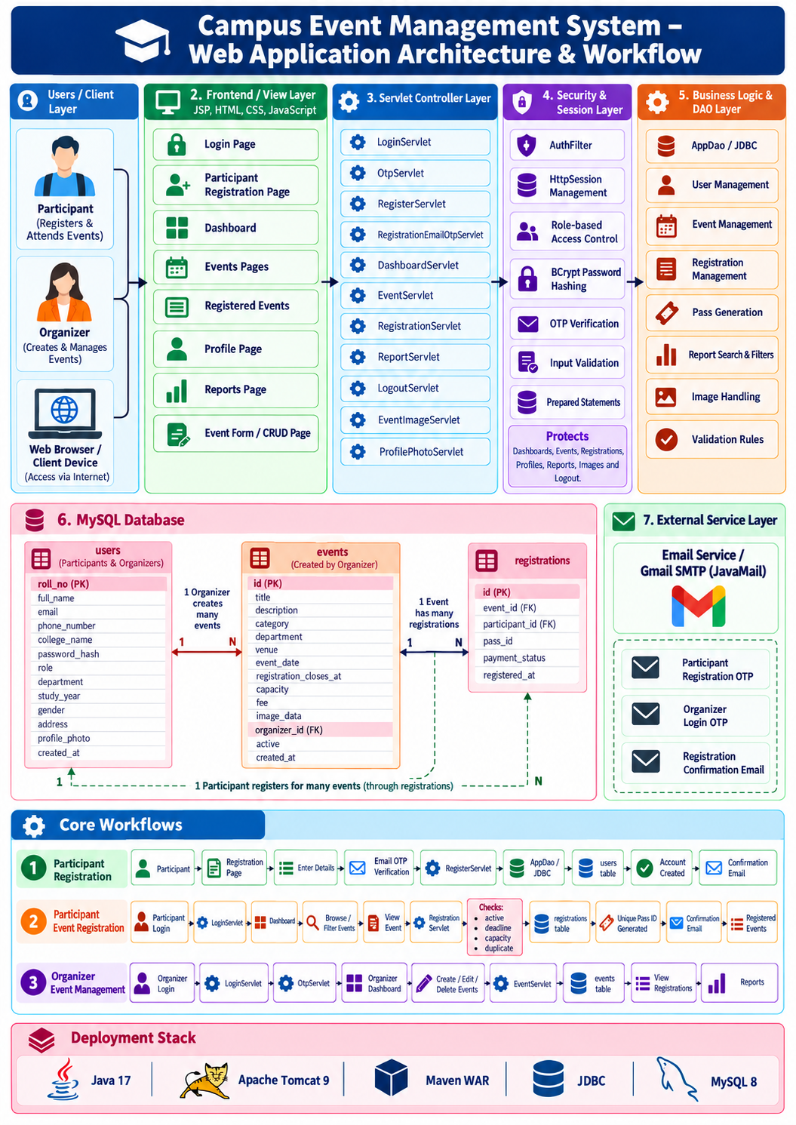
Figure 1 Campus Event Management System architecture and workflow
4. CODING & IMPLEMENTATION
4.1. Login.java
package com.servlets;
import com.dao.AppDao;
import com.model.User;
import com.service.EmailService;
import com.util.PasswordUtil;
import java.io.IOException;
import java.security.SecureRandom;
import javax.servlet.ServletException;
import javax.servlet.annotation.WebServlet;
import javax.servlet.http.HttpServlet;
import javax.servlet.http.HttpServletRequest;
import javax.servlet.http.HttpServletResponse;
import javax.servlet.http.HttpSession;
@WebServlet("/login")
public class Login extends HttpServlet {
private static final long serialVersionUID = 1L;
private static final int AUTHENTICATED_SESSION_SECONDS = 30 * 60;
private static final int OTP_SESSION_SECONDS = 5 * 60;
@Override
protected void doGet(HttpServletRequest request, HttpServletResponse response)
throws ServletException, IOException {
HttpSession session = request.getSession(false);
if (session != null && session.getAttribute("user") != null) {
response.sendRedirect(request.getContextPath() + "/dashboard");
return;
}
String status = request.getParameter("status");
if ("registered".equals(status)) {
request.setAttribute(
"statusMessage",
"Registration completed successfully. Please sign in.");
} else if ("logged-out".equals(status)) {
request.setAttribute("statusMessage", "You have been logged out securely.");
} else if ("session-required".equals(status)) {
request.setAttribute("statusMessage", "Please sign in to continue.");
}
request.getRequestDispatcher("/WEB-INF/views/login.jsp")
.forward(request, response);
}
@Override
protected void doPost(HttpServletRequest request, HttpServletResponse response)
throws ServletException, IOException {
String submittedRollNumber = request.getParameter("rollNo");
String password = request.getParameter("password");
if (submittedRollNumber == null || submittedRollNumber.isBlank()
|| password == null || password.isBlank()) {
showLoginError(request, response, "Enter your roll number and password.");
return;
}
String rollNumber = submittedRollNumber.trim().toUpperCase();
try {
User user = new AppDao().findUser(rollNumber);
if (user == null || !PasswordUtil.verify(password, user.passwordHash())) {
showLoginError(request, response, "Invalid roll number or password.");
return;
}
if ("ORGANIZER".equals(user.role())) {
beginOrganizerOtpLogin(request, response, user);
return;
}
createAuthenticatedSession(request, user);
response.sendRedirect(request.getContextPath() + "/dashboard");
} catch (Exception exception) {
getServletContext().log("Login failed", exception);
showLoginError(
request,
response,
"Login is temporarily unavailable. Please try again shortly.");
}
}
private void beginOrganizerOtpLogin(
HttpServletRequest request,
HttpServletResponse response,
User organizer) throws Exception {
String otp = String.format(
"%06d",
new SecureRandom().nextInt(1_000_000));
HttpSession pendingSession = replaceSession(request);
pendingSession.setAttribute("loginOtp", otp);
pendingSession.setAttribute("pendingUser", organizer);
pendingSession.setAttribute(
"otpExpiresAt",
System.currentTimeMillis() + OTP_SESSION_SECONDS * 1_000L);
pendingSession.setMaxInactiveInterval(OTP_SESSION_SECONDS);
EmailService.sendOrganizerLoginOtp(organizer, otp);
response.sendRedirect(request.getContextPath() + "/verify-otp");
}
private void createAuthenticatedSession(HttpServletRequest request, User user) {
HttpSession authenticatedSession = replaceSession(request);
authenticatedSession.setAttribute("user", user);
authenticatedSession.setMaxInactiveInterval(AUTHENTICATED_SESSION_SECONDS);
}
private HttpSession replaceSession(HttpServletRequest request) {
HttpSession existingSession = request.getSession(false);
if (existingSession != null) {
existingSession.invalidate();
}
return request.getSession(true);
}
private void showLoginError(
HttpServletRequest request,
HttpServletResponse response,
String message) throws ServletException, IOException {
request.setAttribute("errorMessage", message);
request.getRequestDispatcher("/WEB-INF/views/login.jsp")
.forward(request, response);
}
}
4.2. AuthFilter.java
package com.servlets;
import java.io.IOException;
import javax.servlet.Filter;
import javax.servlet.FilterChain;
import javax.servlet.ServletException;
import javax.servlet.ServletRequest;
import javax.servlet.ServletResponse;
import javax.servlet.annotation.WebFilter;
import javax.servlet.http.HttpServletRequest;
import javax.servlet.http.HttpServletResponse;
import javax.servlet.http.HttpSession;
@WebFilter(urlPatterns = {
"/dashboard",
"/events",
"/registrations",
"/profile",
"/event",
"/registration",
"/reports",
"/event-image",
"/profile-photo",
"/logout"
})
public class AuthFilter implements Filter {
@Override
public void doFilter(
ServletRequest servletRequest,
ServletResponse servletResponse,
FilterChain chain) throws IOException, ServletException {
HttpServletRequest request = (HttpServletRequest) servletRequest;
HttpServletResponse response = (HttpServletResponse) servletResponse;
HttpSession session = request.getSession(false);
if (session == null || session.getAttribute("user") == null) {
response.sendRedirect(
request.getContextPath() + "/login?status=session-required");
return;
}
response.setHeader("Cache-Control", "no-store, no-cache, must-revalidate");
response.setHeader("Pragma", "no-cache");
response.setDateHeader("Expires", 0);
chain.doFilter(request, response);
}
}
4.3. RegisterServlet.java
package com.servlets;
import com.dao.AppDao;
import com.model.User;
import com.service.EmailService;
import com.util.PasswordUtil;
import java.io.IOException;
import java.util.Set;
import javax.servlet.ServletException;
import javax.servlet.annotation.MultipartConfig;
import javax.servlet.annotation.WebServlet;
import javax.servlet.http.HttpServlet;
import javax.servlet.http.HttpServletRequest;
import javax.servlet.http.HttpServletResponse;
import javax.servlet.http.HttpSession;
import javax.servlet.http.Part;
@WebServlet("/register")
@MultipartConfig(maxFileSize = 2_097_152)
public class RegisterServlet extends HttpServlet {
private static final long serialVersionUID = 1L;
private static final Set<String> DEPARTMENTS = Set.of(
"CSE", "IT", "AI&DS", "CSM", "EEE", "ECE", "MECH", "CIVIL", "ASE");
private static final Set<String> COLLEGES = Set.of(
"Lakireddy Bali Reddy college of Engineering",
"Bapatla Engineering college",
"SRK Institute of Technology",
"Andhra Loyola Institute of Engineering and Technology",
"Velagapudi Ramakrishna Siddhartha Engineering College",
"PSCMR College of Engineering and Technology",
"Prasad V. Potluri Siddhartha Institute Of Technology",
"RK COLLEGE OF ENGINEERING",
"MIC College of Technology",
"Amrita Sai Institute of Science and Technology");
private static final Set<String> GENDERS = Set.of("Male", "Female", "Other");
@Override
protected void doGet(HttpServletRequest request, HttpServletResponse response)
throws ServletException, IOException {
HttpSession session = request.getSession(false);
if (session != null && session.getAttribute("user") != null) {
response.sendRedirect(request.getContextPath() + "/dashboard");
return;
}
request.getRequestDispatcher("/WEB-INF/views/register.jsp")
.forward(request, response);
}
@Override
protected void doPost(HttpServletRequest request, HttpServletResponse response)
throws ServletException, IOException {
String rollNumber = normalize(request.getParameter("rollNo")).toUpperCase();
String email = normalize(request.getParameter("email")).toLowerCase();
String password = normalize(request.getParameter("password"));
HttpSession session = request.getSession(false);
String verifiedEmail = session == null
? null
: (String) session.getAttribute("verifiedRegistrationEmail");
if (verifiedEmail == null || !verifiedEmail.equals(email)) {
request.setAttribute(
"errorMessage",
"Verify this email address with OTP before submitting.");
request.getRequestDispatcher("/WEB-INF/views/register.jsp")
.forward(request, response);
return;
}
AppDao appDao = new AppDao();
boolean participantCreated = false;
try {
validateRegistration(request, rollNumber, password);
Part profilePhotoPart = request.getPart("profilePhoto");
validateProfilePhoto(profilePhotoPart);
String conflict = appDao.registrationConflict(
rollNumber,
email,
normalize(request.getParameter("phoneNumber")));
if (conflict != null) {
throw new IllegalArgumentException(conflict);
}
byte[] profilePhoto = profilePhotoPart.getInputStream().readAllBytes();
User participant = buildParticipant(request, rollNumber, email);
appDao.createParticipant(
participant,
PasswordUtil.hash(password),
profilePhoto,
profilePhotoPart.getContentType());
participantCreated = true;
session.removeAttribute("verifiedRegistrationEmail");
sendRegistrationConfirmation(participant);
response.sendRedirect(
request.getContextPath() + "/login?status=registered");
} catch (Exception exception) {
if (participantCreated) {
removeIncompleteParticipant(appDao, rollNumber);
}
getServletContext().log("Participant registration failed", exception);
request.setAttribute("errorMessage", registrationErrorMessage(exception));
request.getRequestDispatcher("/WEB-INF/views/register.jsp")
.forward(request, response);
}
}
private void validateRegistration(
HttpServletRequest request,
String rollNumber,
String password) {
String confirmPassword = requireText(
request,
"confirmPassword",
"Confirm password");
requireText(request, "fullName", "Full name");
requireText(request, "rollNo", "Roll number");
requireText(request, "email", "Email");
requireText(request, "phoneNumber", "Phone number");
requireText(request, "collegeName", "College name");
requireText(request, "department", "Department");
requireText(request, "year", "Year");
requireText(request, "gender", "Gender");
requireText(request, "address", "Address");
if (!password.equals(confirmPassword)) {
throw new IllegalArgumentException("Passwords do not match.");
}
if (!rollNumber.matches("[A-Z0-9]{5,20}")) {
throw new IllegalArgumentException(
"Roll number must contain 5 to 20 letters or numbers.");
}
String phoneNumber = normalize(request.getParameter("phoneNumber"));
if (!phoneNumber.matches("[6-9][0-9]{9}")) {
throw new IllegalArgumentException("Enter a valid 10-digit mobile number.");
}
String collegeName = normalize(request.getParameter("collegeName"));
if (!COLLEGES.contains(collegeName)) {
throw new IllegalArgumentException("Select a valid college name.");
}
String department = normalize(request.getParameter("department"));
if (!DEPARTMENTS.contains(department)) {
throw new IllegalArgumentException("Select a valid department.");
}
String gender = normalize(request.getParameter("gender"));
if (!GENDERS.contains(gender)) {
throw new IllegalArgumentException("Select a valid gender.");
}
int year;
try {
year = Integer.parseInt(normalize(request.getParameter("year")));
} catch (NumberFormatException exception) {
throw new IllegalArgumentException("Select a valid study year.");
}
if (year < 1 || year > 4) {
throw new IllegalArgumentException("Select a valid study year.");
}
String strongPasswordPattern =
"^(?=.*[A-Z])(?=.*[a-z])(?=.*\\d)"
+ "(?=.*[^A-Za-z0-9]).{6,15}$";
if (!password.matches(strongPasswordPattern)) {
throw new IllegalArgumentException(
"Password must be 6 to 15 characters and contain at least one "
+ "lowercase letter, uppercase letter, number and special symbol.");
}
}
private String requireText(
HttpServletRequest request,
String parameter,
String label) {
String value = request.getParameter(parameter);
if (value == null || value.isBlank()) {
throw new IllegalArgumentException(label + " is required.");
}
return value.trim();
}
private String normalize(String value) {
return value == null ? "" : value.trim();
}
private void validateProfilePhoto(Part profilePhotoPart) {
if (profilePhotoPart == null || profilePhotoPart.getSize() == 0) {
throw new IllegalArgumentException("Profile photo is required.");
}
String contentType = profilePhotoPart.getContentType();
boolean supportedType = contentType != null
&& contentType.matches("image/(jpeg|png|webp)");
if (!supportedType) {
throw new IllegalArgumentException(
"Upload a valid JPG, PNG or WEBP profile photo.");
}
}
private User buildParticipant(
HttpServletRequest request,
String rollNumber,
String email) {
return new User(
rollNumber,
request.getParameter("fullName").trim(),
email,
request.getParameter("phoneNumber").trim(),
request.getParameter("collegeName").trim(),
null,
"PARTICIPANT",
request.getParameter("department").trim(),
Integer.parseInt(request.getParameter("year")),
request.getParameter("gender").trim(),
request.getParameter("address").trim());
}
private void sendRegistrationConfirmation(User participant) {
try {
EmailService.sendParticipantWelcome(participant);
} catch (Exception mailException) {
getServletContext().log(
"Registration saved but confirmation email failed",
mailException);
}
}
private void removeIncompleteParticipant(AppDao appDao, String rollNumber) {
try {
appDao.deleteUser(rollNumber);
} catch (Exception cleanupException) {
getServletContext().log(
"Unable to remove incomplete participant",
cleanupException);
}
}
private String registrationErrorMessage(Exception exception) {
String message = exception.getMessage();
if (message != null && message.toLowerCase().contains("duplicate")) {
String lowerMessage = message.toLowerCase();
if (lowerMessage.contains("phone")) {
return "Phone number already exists.";
}
if (lowerMessage.contains("email")) {
return "Email address already exists.";
}
if (lowerMessage.contains("primary") || lowerMessage.contains("roll")) {
return "Roll number already exists.";
}
return "Roll number, email address, or phone number already exists.";
}
return message == null ? "Registration failed." : message;
}
}
4.4. DashboardServlet.java
package com.servlets;
import com.dao.AppDao;
import com.model.Event;
import com.model.ParticipantEventRegistration;
import com.model.User;
import java.io.IOException;
import java.util.List;
import javax.servlet.ServletException;
import javax.servlet.annotation.WebServlet;
import javax.servlet.http.HttpServlet;
import javax.servlet.http.HttpServletRequest;
import javax.servlet.http.HttpServletResponse;
@WebServlet(urlPatterns = {
"/dashboard",
"/events",
"/registrations",
"/profile"
})
public class DashboardServlet extends HttpServlet {
private static final long serialVersionUID = 1L;
@Override
protected void doGet(HttpServletRequest request, HttpServletResponse response)
throws ServletException, IOException {
try {
AppDao appDao = new AppDao();
User user = (User) request.getSession().getAttribute("user");
request.setAttribute("activeSection", activeSection(request));
if ("PARTICIPANT".equals(user.role())) {
List<Event> availableEvents = appDao.events(true);
List<ParticipantEventRegistration> registrations =
appDao.participantRegistrations(user.rollNo());
if ("events".equals(request.getAttribute("activeSection"))) {
availableEvents = filterEvents(
availableEvents,
request.getParameter("category"),
request.getParameter("department"));
} else if ("registrations".equals(
request.getAttribute("activeSection"))) {
registrations = filterRegistrations(
registrations,
request.getParameter("category"),
request.getParameter("department"));
}
request.setAttribute("availableEvents", availableEvents);
request.setAttribute(
"participantRegistrations",
registrations);
request.getRequestDispatcher("/WEB-INF/views/userdashboard.jsp")
.forward(request, response);
return;
}
if ("registrations".equals(request.getAttribute("activeSection"))) {
response.sendRedirect(request.getContextPath() + "/reports");
return;
}
List<Event> events = appDao.events(false);
if ("events".equals(request.getAttribute("activeSection"))) {
events = filterEvents(
events,
request.getParameter("category"),
request.getParameter("department"));
}
request.setAttribute("events", events);
request.getRequestDispatcher("/WEB-INF/views/organizerdashboard.jsp")
.forward(request, response);
} catch (Exception exception) {
throw new ServletException("Unable to load dashboard.", exception);
}
}
private String activeSection(HttpServletRequest request) {
return switch (request.getServletPath()) {
case "/events" -> "events";
case "/registrations" -> "registrations";
case "/profile" -> "profile";
default -> "dashboard";
};
}
private List<Event> filterEvents(
List<Event> events,
String category,
String department) {
return events.stream()
.filter(event -> category == null
|| category.isBlank()
|| category.equals(event.category()))
.filter(event -> department == null
|| department.isBlank()
|| department.equals(event.department()))
.toList();
}
private List<ParticipantEventRegistration> filterRegistrations(
List<ParticipantEventRegistration> registrations,
String category,
String department) {
return registrations.stream()
.filter(registration -> category == null
|| category.isBlank()
|| category.equals(registration.event().category()))
.filter(registration -> department == null
|| department.isBlank()
|| department.equals(registration.event().department()))
.toList();
}
}
4.5. EventServlet.java
package com.servlets;
import com.dao.AppDao;
import com.model.Event;
import com.model.User;
import java.io.IOException;
import java.io.InputStream;
import java.time.LocalDate;
import java.time.LocalDateTime;
import java.time.LocalTime;
import java.util.Set;
import javax.servlet.ServletException;
import javax.servlet.annotation.MultipartConfig;
import javax.servlet.annotation.WebServlet;
import javax.servlet.http.HttpServlet;
import javax.servlet.http.HttpServletRequest;
import javax.servlet.http.HttpServletResponse;
import javax.servlet.http.Part;
@WebServlet("/event")
@MultipartConfig(maxFileSize = 5 * 1024 * 1024)
public class EventServlet extends HttpServlet {
private static final long serialVersionUID = 1L;
private static final Set<String> ALLOWED_IMAGE_TYPES = Set.of(
"image/jpeg",
"image/png",
"image/webp");
private static final Set<String> CATEGORIES = Set.of(
"Technical", "Cultural", "Sports", "Workshop", "Seminar");
private static final Set<String> DEPARTMENTS = Set.of(
"CSE", "IT", "AI&DS", "CSM", "EEE", "ECE", "MECH", "CIVIL", "ASE");
@Override
protected void doGet(HttpServletRequest request, HttpServletResponse response)
throws ServletException, IOException {
String eventId = request.getParameter("id");
User user = (User) request.getSession().getAttribute("user");
if (eventId == null || eventId.isBlank()) {
if (!"ORGANIZER".equals(user.role())) {
response.sendError(HttpServletResponse.SC_FORBIDDEN);
return;
}
request.getRequestDispatcher("/WEB-INF/views/event-form.jsp")
.forward(request, response);
return;
}
try {
Event event = new AppDao().event(Integer.parseInt(eventId));
if (event == null) {
response.sendError(HttpServletResponse.SC_NOT_FOUND, "Event not found.");
return;
}
request.setAttribute("event", event);
request.setAttribute("backPath", participantBackPath(request));
request.getRequestDispatcher("/WEB-INF/views/event-form.jsp")
.forward(request, response);
} catch (NumberFormatException exception) {
response.sendError(HttpServletResponse.SC_BAD_REQUEST, "Invalid event ID.");
} catch (Exception exception) {
throw new ServletException("Unable to load event.", exception);
}
}
@Override
protected void doPost(HttpServletRequest request, HttpServletResponse response)
throws ServletException, IOException {
try {
requireOrganizer(request);
AppDao appDao = new AppDao();
if ("delete".equals(request.getParameter("action"))) {
appDao.deleteEvent(Integer.parseInt(request.getParameter("id")));
} else {
User organizer = (User) request.getSession().getAttribute("user");
String eventId = request.getParameter("id");
int id = eventId == null || eventId.isBlank()
? 0
: Integer.parseInt(eventId);
LocalDateTime eventDateTime = dateTime(
required(request, "eventDate", "Event date"),
required(request, "eventTime", "Event start time"));
LocalDateTime registrationClosesAt = dateTime(
required(
request,
"registrationCloseDate",
"Registration closing date"),
required(
request,
"registrationCloseTime",
"Registration closing time"));
validateDates(eventDateTime, registrationClosesAt);
Part imagePart = request.getPart("eventImage");
byte[] imageData = readImage(imagePart);
if (id == 0 && imageData == null) {
throw new IllegalArgumentException("Event image is required.");
}
String imageType = imageData == null ? null : imagePart.getContentType();
boolean hasImage = imageData != null;
if (!hasImage && id > 0) {
Event existingEvent = appDao.event(id);
hasImage = existingEvent != null && existingEvent.hasImage();
}
int capacity = Integer.parseInt(required(
request,
"capacity",
"Capacity"));
double fee = Double.parseDouble(required(request, "fee", "Fee"));
String category = required(request, "category", "Category");
String department = required(request, "department", "Department");
if (capacity < 1 || fee < 0) {
throw new IllegalArgumentException(
"Capacity must be at least 1 and fee cannot be negative.");
}
if (!CATEGORIES.contains(category)) {
throw new IllegalArgumentException("Select a valid event category.");
}
if (!DEPARTMENTS.contains(department)) {
throw new IllegalArgumentException("Select a valid department.");
}
Event event = new Event(
id,
required(request, "title", "Event title"),
required(request, "description", "Description"),
category,
department,
required(request, "venue", "Venue"),
eventDateTime,
registrationClosesAt,
capacity,
fee,
hasImage,
organizer.rollNo(),
request.getParameter("active") != null,
0);
appDao.saveEvent(event, imageData, imageType);
}
response.sendRedirect(request.getContextPath() + "/events");
} catch (SecurityException exception) {
response.sendError(HttpServletResponse.SC_FORBIDDEN);
} catch (NumberFormatException exception) {
response.sendError(HttpServletResponse.SC_BAD_REQUEST, "Invalid event data.");
} catch (IllegalArgumentException exception) {
response.sendError(HttpServletResponse.SC_BAD_REQUEST, exception.getMessage());
} catch (Exception exception) {
throw new ServletException("Unable to save event.", exception);
}
}
private String participantBackPath(HttpServletRequest request) {
String source = request.getParameter("from");
return "registrations".equals(source) ? "registrations" : "events";
}
private String required(
HttpServletRequest request,
String parameter,
String label) {
String value = request.getParameter(parameter);
if (value == null || value.isBlank()) {
throw new IllegalArgumentException(label + " is required.");
}
return value.trim();
}
private LocalDateTime dateTime(String date, String time) {
return LocalDateTime.of(LocalDate.parse(date), LocalTime.parse(time));
}
private void validateDates(
LocalDateTime eventDateTime,
LocalDateTime registrationClosesAt) {
if (!registrationClosesAt.isBefore(eventDateTime)) {
throw new IllegalArgumentException(
"Registration closing time must be before the event starts.");
}
if (registrationClosesAt.isBefore(LocalDateTime.now())) {
throw new IllegalArgumentException(
"Registration closing date and time must be in the future.");
}
}
private byte[] readImage(Part imagePart) throws IOException, ServletException {
if (imagePart == null || imagePart.getSize() == 0) {
return null;
}
if (!ALLOWED_IMAGE_TYPES.contains(imagePart.getContentType())) {
throw new IllegalArgumentException("Event image must be JPG, PNG, or WEBP.");
}
try (InputStream input = imagePart.getInputStream()) {
return input.readAllBytes();
}
}
private void requireOrganizer(HttpServletRequest request) {
User user = (User) request.getSession().getAttribute("user");
if (!"ORGANIZER".equals(user.role())) {
throw new SecurityException("Organizer access required.");
}
}
}
4.6. RegistrationServlet.java
package com.servlets;
import com.dao.AppDao;
import com.model.Event;
import com.model.User;
import com.service.EmailService;
import java.io.IOException;
import java.sql.SQLException;
import javax.servlet.ServletException;
import javax.servlet.annotation.WebServlet;
import javax.servlet.http.HttpServlet;
import javax.servlet.http.HttpServletRequest;
import javax.servlet.http.HttpServletResponse;
@WebServlet("/registration")
public class RegistrationServlet extends HttpServlet {
private static final long serialVersionUID = 1L;
@Override
protected void doPost(HttpServletRequest request, HttpServletResponse response)
throws ServletException, IOException {
User participant = (User) request.getSession().getAttribute("user");
if (!"PARTICIPANT".equals(participant.role())) {
response.sendError(HttpServletResponse.SC_FORBIDDEN);
return;
}
String redirectPath = "/events";
try {
int eventId = Integer.parseInt(request.getParameter("eventId"));
AppDao appDao = new AppDao();
Event event = appDao.event(eventId);
if (event == null) {
request.getSession().setAttribute("flash", "Event not found.");
response.sendRedirect(request.getContextPath() + redirectPath);
return;
}
String passId = appDao.register(eventId, participant.rollNo());
sendConfirmationEmail(participant, event, passId);
request.getSession().setAttribute(
"flash",
"Registration complete. Pass ID: " + passId);
redirectPath = "/registrations";
} catch (NumberFormatException exception) {
request.getSession().setAttribute("flash", "Invalid event selection.");
} catch (SQLException exception) {
handleRegistrationDatabaseError(request, exception);
} catch (Exception exception) {
getServletContext().log("Event registration failed", exception);
request.getSession().setAttribute(
"flash",
"Registration failed. Please try again.");
}
response.sendRedirect(request.getContextPath() + redirectPath);
}
private void handleRegistrationDatabaseError(
HttpServletRequest request,
SQLException exception) {
String message = exception.getMessage() == null
? ""
: exception.getMessage().toLowerCase();
if (message.contains("duplicate")) {
request.getSession().setAttribute(
"flash",
"You are already registered for this event.");
return;
}
if (message.contains("full or unavailable")) {
request.getSession().setAttribute(
"flash",
"This event is full or no longer available for registration.");
return;
}
getServletContext().log("Event registration failed", exception);
request.getSession().setAttribute(
"flash",
"Registration failed. Please try again.");
}
private void sendConfirmationEmail(User participant, Event event, String passId) {
try {
EmailService.sendEventRegistrationReceipt(participant, event, passId);
} catch (Exception exception) {
getServletContext().log(
"Event registration saved but confirmation email failed",
exception);
}
}
}
4.7. PasswordUtil.java
package com.util;
import org.mindrot.jbcrypt.BCrypt;
public final class PasswordUtil {
private static final int BCRYPT_COST = 12;
private PasswordUtil() {
}
public static String hash(String plainTextPassword) {
if (plainTextPassword == null || plainTextPassword.isEmpty()) {
throw new IllegalArgumentException("Password must not be empty.");
}
return BCrypt.hashpw(
plainTextPassword,
BCrypt.gensalt(BCRYPT_COST));
}
public static boolean verify(String plainTextPassword, String storedHash) {
if (plainTextPassword == null
|| storedHash == null
|| !storedHash.startsWith("$2")) {
return false;
}
try {
return BCrypt.checkpw(plainTextPassword, storedHash);
} catch (IllegalArgumentException exception) {
return false;
}
}
}
5. RESULTS
5.1. Login Page  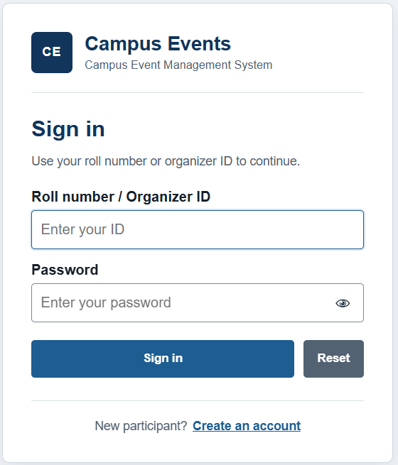 | 5.2. Participant Registration Form  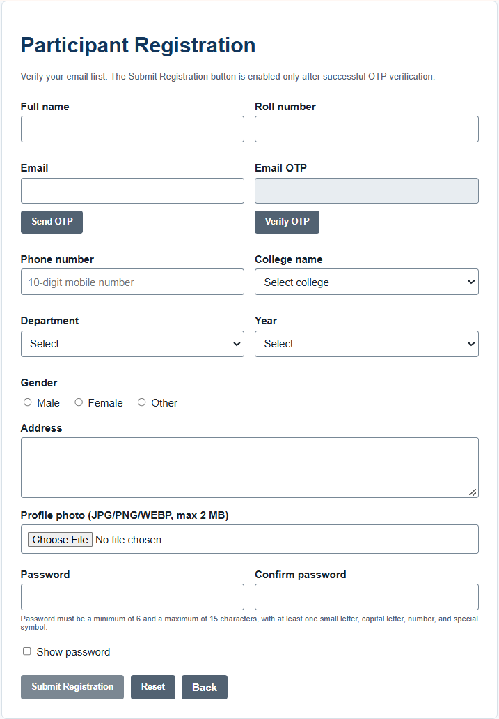
5.3. Organizer OTP Verification Form  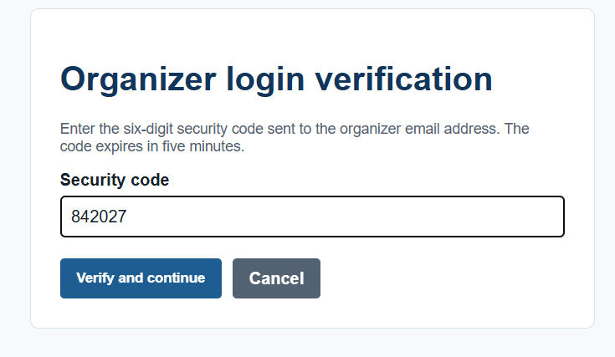 | 5.4. Organizer Login OTP Email  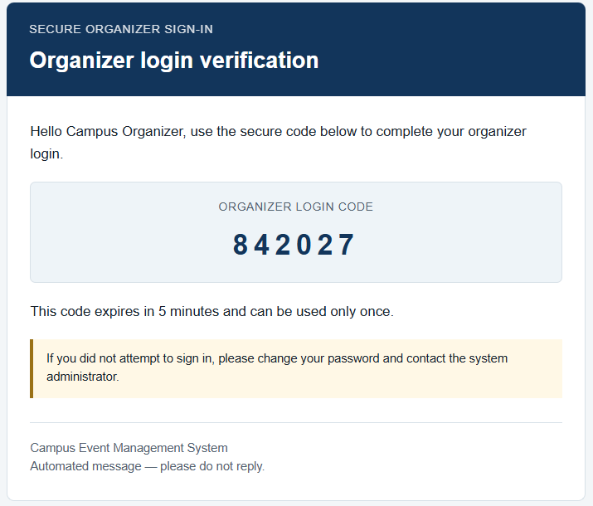
5.5. Organizer Dashboard  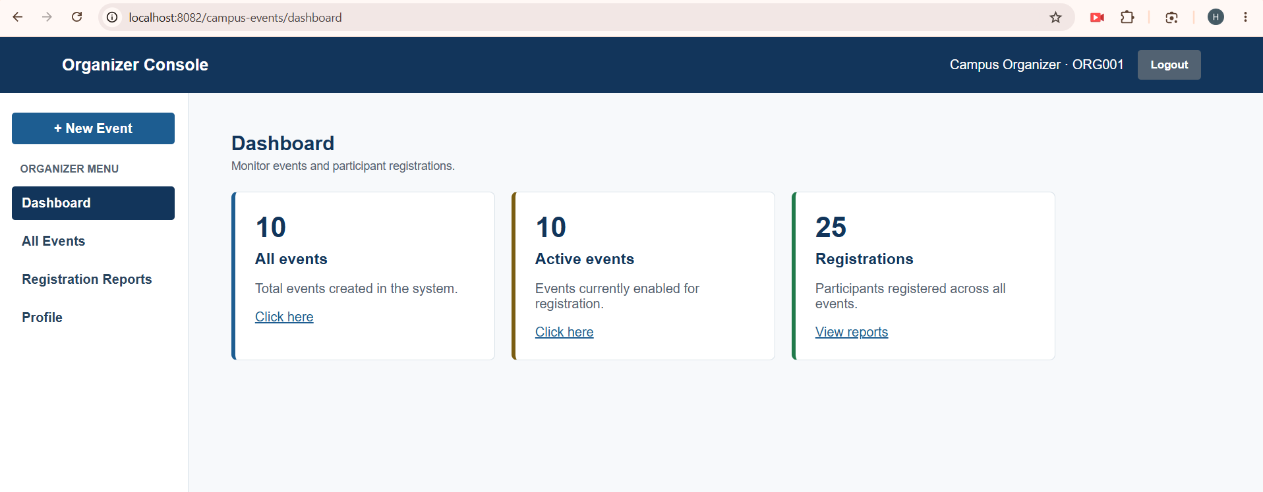 | 5.6. Organizer All Events  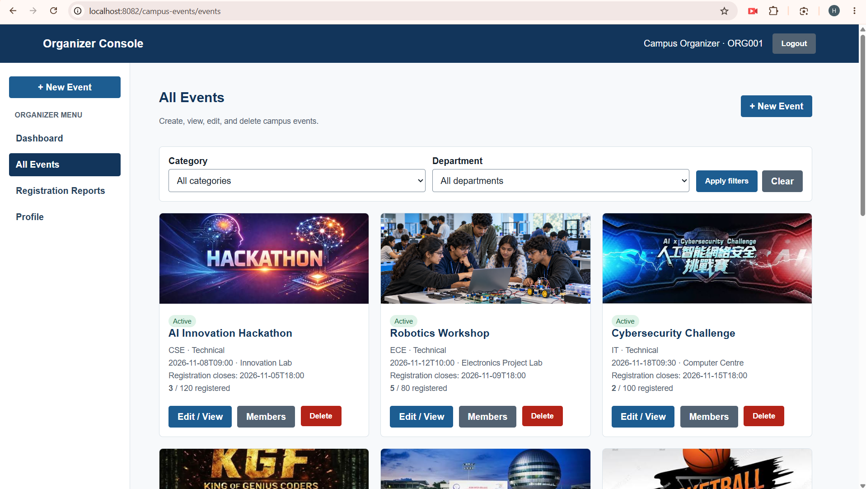

5.7. Registration Reports  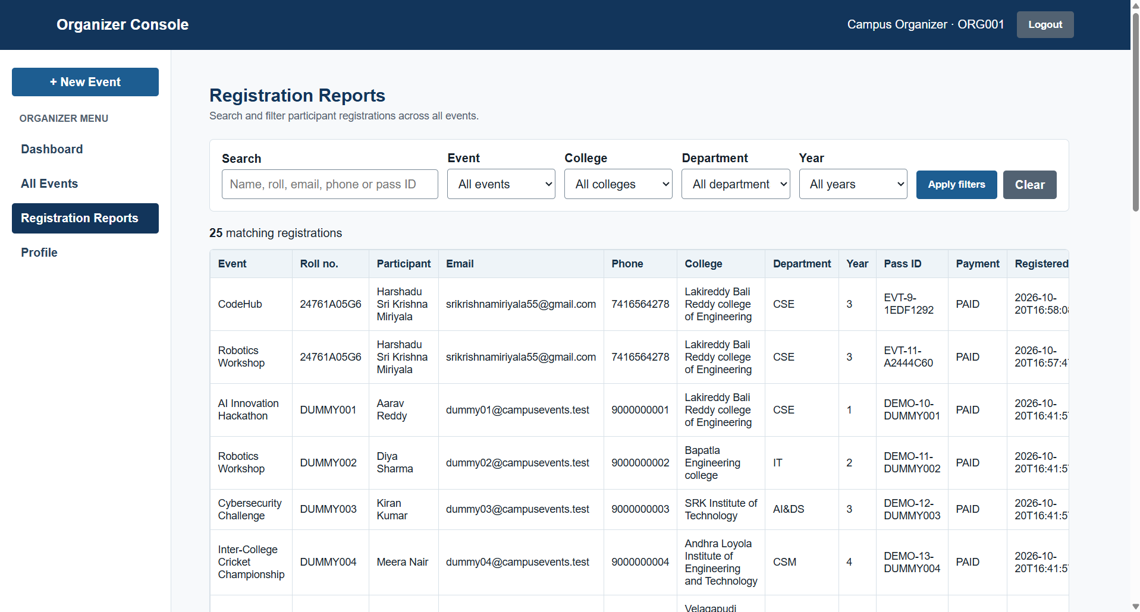 | 5.8. Organizer Profile  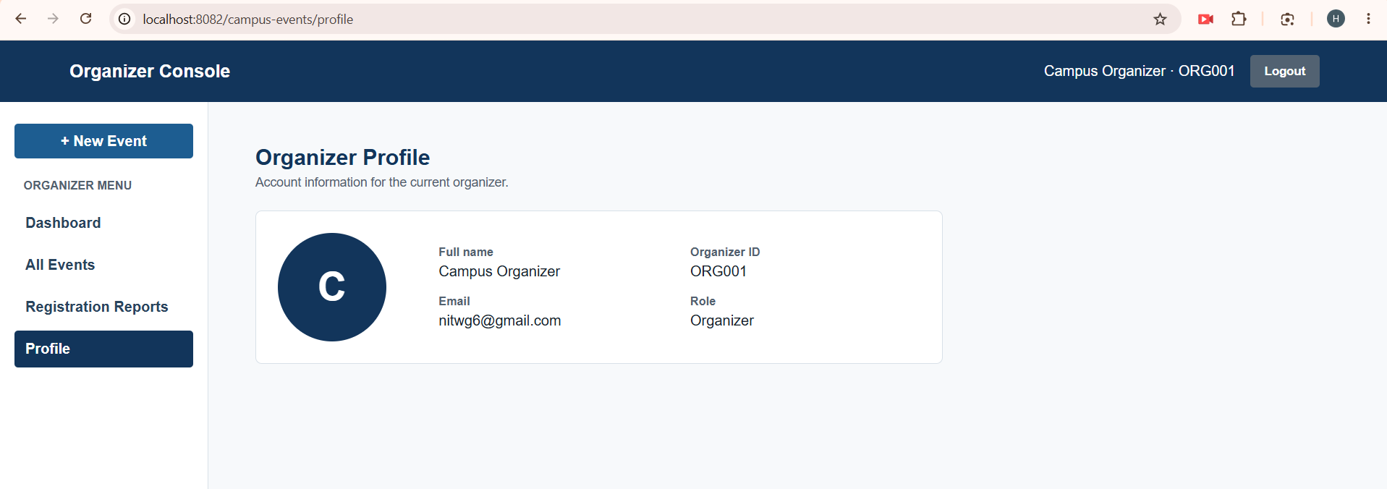
5.9. Participant Dashboard  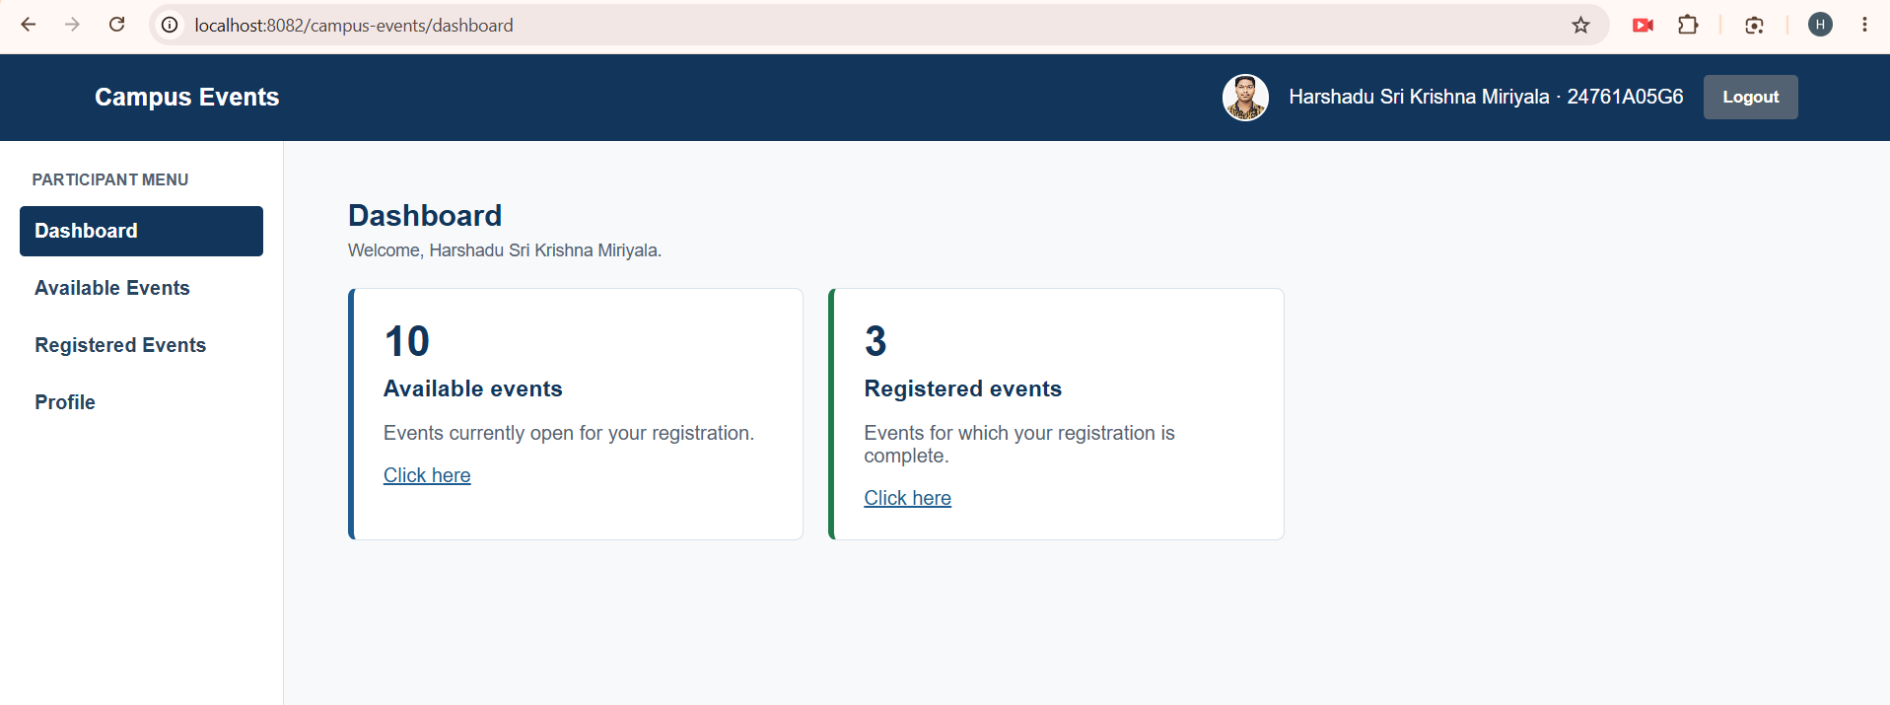 | 5.10. Participant Registered Events  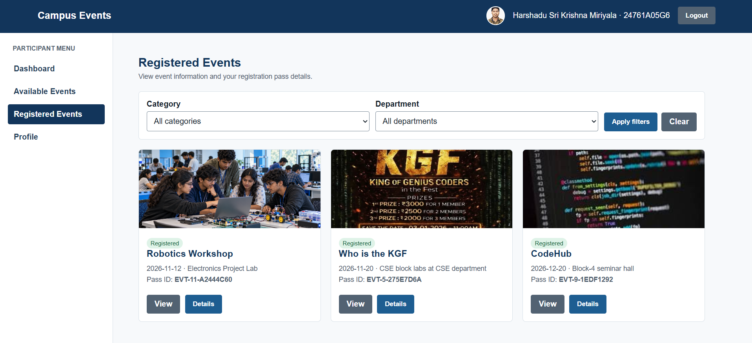
5.11. Participant Profile  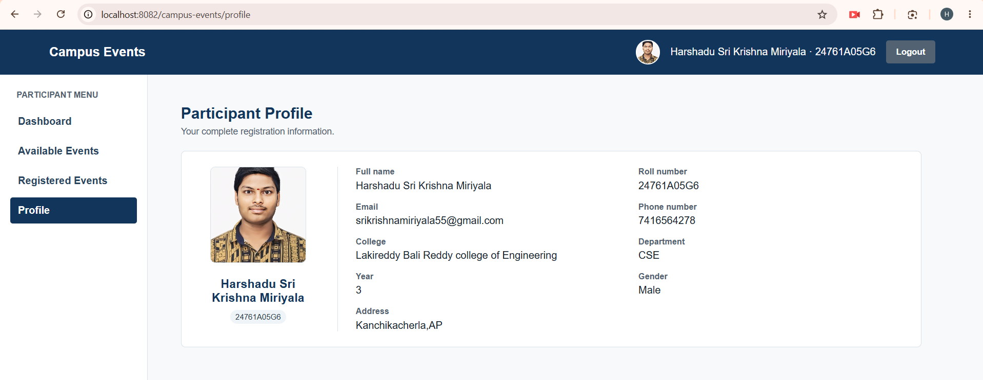 | 5.12. Event Registration Confirmation Email  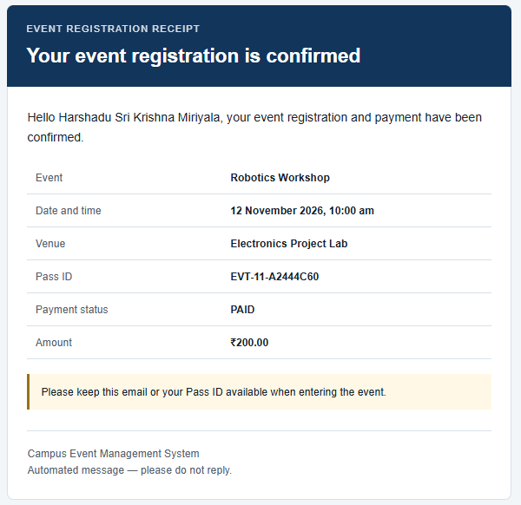
6. CONCLUSION
Campus Event Management System brings event discovery, account verification, registration, pass retrieval, and organizer reporting into one Java web application. Participant and organizer interfaces reflect their different permissions while using the same persistent records. This provides a practical demonstration of how browser forms, server controllers, relational data, and email services cooperate in a full stack project.
The application uses unique student identities, BCrypt password hashes, email OTP workflows, session-based authentication, Servlet role checks, and prepared database operations. Event deadlines, capacities, and duplicate registration constraints connect published information with accepted registrations. Category and department filters help participants browse, while organizer search and academic filters support inspection of complete member records.
The current mini project simulates payment as PAID and does not include cancellation, feedback, or password recovery. Further work can add verified payment callbacks, QR attendance, exportable reports, administrative organizer management, automated tests, and production secret handling. These additions can extend the core without changing its separation of views, controllers, models, data access, and email responsibilities.
7. REFERENCES
- Oracle. Java Platform, Standard Edition 17 API Specification. https://docs.oracle.com/en/java/javase/17/docs/api/
- Oracle. Java Database Connectivity (JDBC) Documentation. https://docs.oracle.com/javase/8/docs/technotes/guides/jdbc/
- Apache Software Foundation. Apache Tomcat 9 Documentation. https://tomcat.apache.org/tomcat-9.0-doc/
- Oracle. MySQL 8.0 Reference Manual.
https://dev.mysql.com/doc/refman/8.0/en/
- Apache Software Foundation. Apache Maven Documentation. https://maven.apache.org/guides/
- MDN Web Docs. HTML, CSS, and JavaScript Documentation. https://developer.mozilla.org/en-US/docs/Web
- JavaMail Project. JavaMail API Documentation.
https://javaee.github.io/javamail/
- Damien Miller. jBCrypt: BCrypt Password Hashing for Java. https://www.mindrot.org/projects/jBCrypt/
- NSR Blogspot.
https://nsr-materials.blogspot.com/
- GeeksforGeeks.
https://www.geeksforgeeks.org/

